**Student Name:** Okeke Nkasiobi Irene

**University:** Nnamdi Azikiwe University

**Major:** Human Physiology

**Internship Duration:** February 12th, 2025 – March 1st, 2025

**Company:** Hack Secure

**Domain:** Cyber Security

**Mentor:** Mr. Aman Pandey

**Assistant Mentor:** Mr. Aman Pandey

**Coordinator:** Mr. Prabhat Raj

**Objectives**

My primary objectives is to:

* Gain more knowledge on offensive security tools like metasploit
* Gain more understanding web application exploitations like SQL injection
* Gain knowledge in identifying, analyzing and mitigating cybersecurity threats and vulnerabilities.
* Gain more experience on cybersecurity tools through real-life scenarios.

**Tasks and Responsibilities (Red Teaming)**

**Vulnerability Assessment (Port Scanning):** I conducted a complete scanning of the provided target website <http://testphp.vulnweb.com/> with nmap to find open ports on the website with the command code nmap -sV <http://testphp.vulnweb.com/> and the following output was obtained:

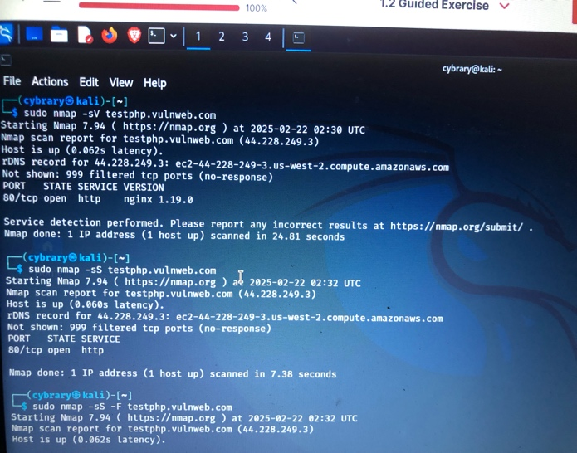

**Brute Force:** I learnt the art of deep enumeration through brute force with the tool gobuster to find hidden directories on the target. Gobuster dir –u <http://testphp.vulnweb.com/> -w /usr/share/wordlists/dirb/common.txt and the following output was gotten:

**Network analysis:**  I created an account on the target website using fake login details and intercepted the post request using wireshark thereby successfully capturing the login password and username on wireshark.

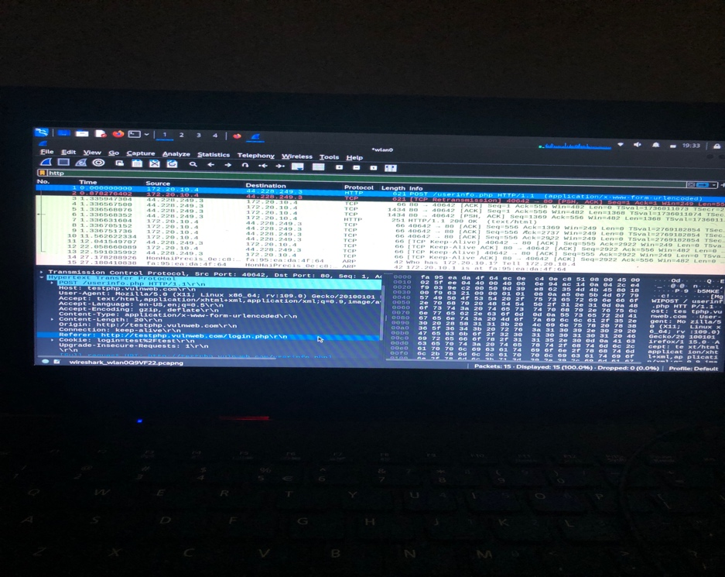

**Red team fundamentals:**  using tryhackme stimulated room for offensive security I successfully understood the concepts on the art of phishing, social engineering, TTP and the framework of the cyberkill chain. I also learnt the mitigation of social engineering and phishing which mainly include people awareness.

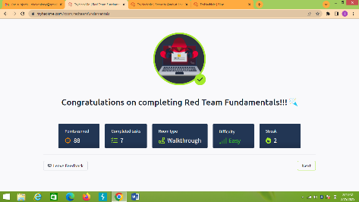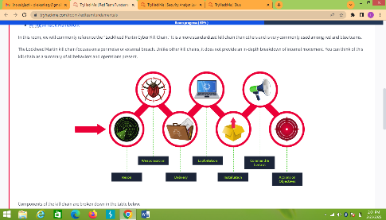

**Common Attacks:**  using the tryhackme free stimulated common attacks room where I learnt the TTP of ransomware and malware attacks which are most common frequent attacks on many organizations like Microsoft. I also learnt how password manager and authentication works. Mitigation of these cybercrimes was understood such as daily backup of data both online and offline to prevent attacks for ransomware.

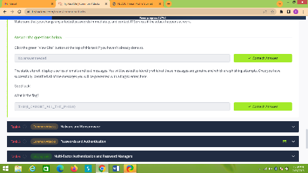

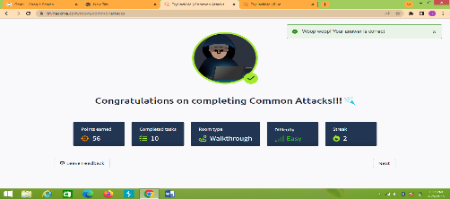

**Exploitation:** using the tryhackme CTF room, I explored how hackers exploit vulnerability on a device through performing initial access of the target, lateral movement and maintaining persistence on a compromised device. I also learnt post-exploitation attacks such as data exfiltration and credential harvesting. I also explored the basic commands of linux such as “ls”.

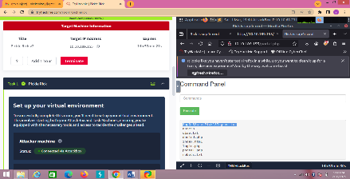 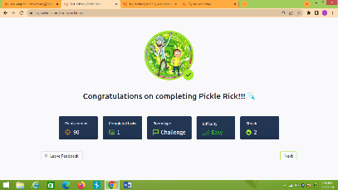 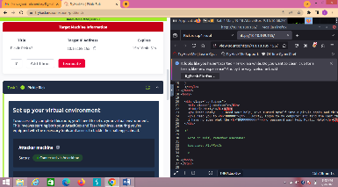

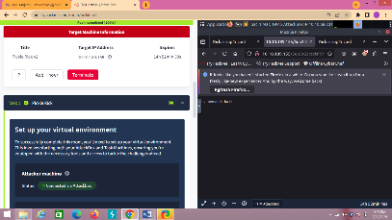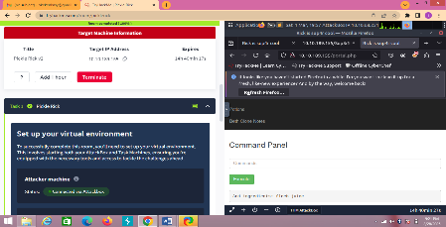

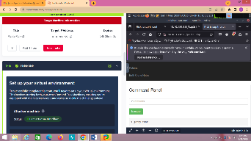

**Script execution command:** using python IDE I designed a program that evaluates the strength of passwords. With this , I advanced my understanding of programming in python.

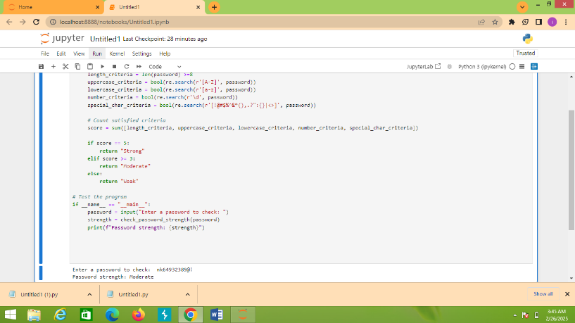

**Learning outcomes:**

* I obtained valuable knowledge in penetration testing, network analysis, brute force and cybersecurity tools like nmap and gobuster
* I gained more familiar environment using a programming language, python.
* I developed critical thinking and problem-solving skills while doing these tasks.

**Challenges and solutions**

* Firstly writing a program in python was always tasking but with this task on python I came to appreciate python more.
* Using cybersecurity tools like gobuster for deep enumeration was a foreign concept for me but with this task I was able to learn more on it.

**Conclusion**

My internship at **HACK SECURE** was a wonderful experience I would even like to participate. It expanded in many cybersecurity tools and concepts. It also introduced me to basic linux commans and penetration testing TTP.

**Acknowledgements**

I express my profound appreciation to HACK SECURE especially my mentor, Mr. Aman Pandey and assistant mentor Mr. Prabhat Raj, for their guidance and support throughout my internship.

This report encompasses the essence of my internship experience. It showcases the journey of my growth, learning, skill and professional development in the field of cybersecurity.